PROJECT-2

- Which state has the highest number of hotels? Depict this via a bar graph that compares all states.
As the bar graph suggests, Kerela has the highest no of Hotels.
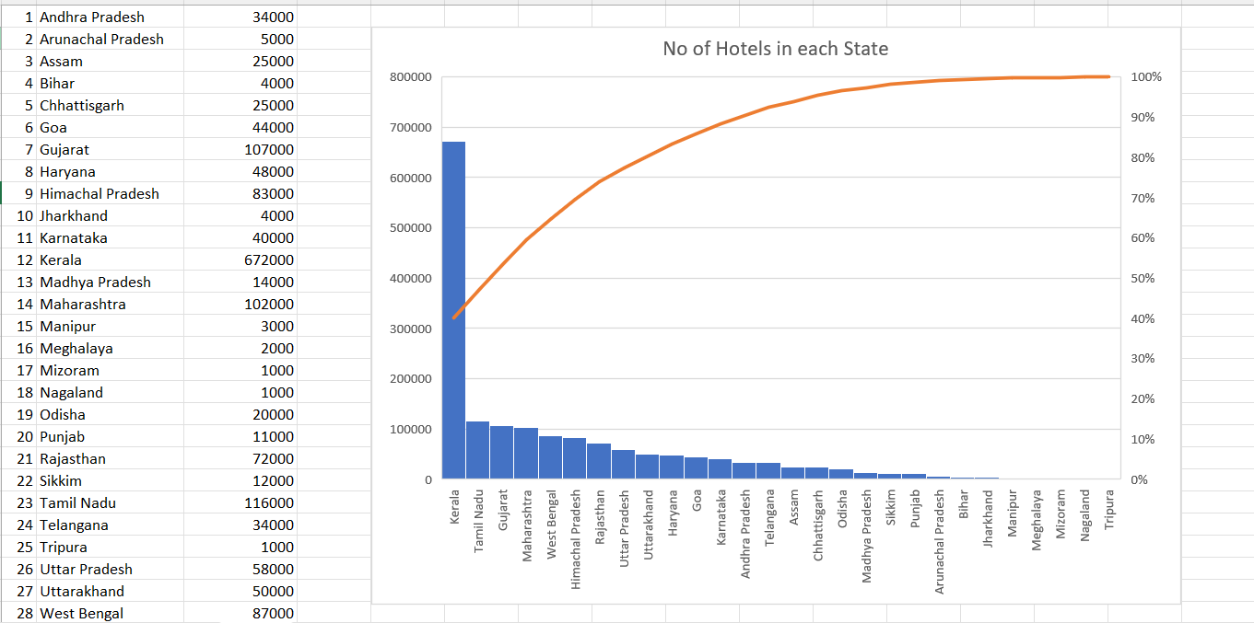

- Which states have three types of climatic conditions? (convert the map, an unstructured data, to an Excel file in a structured format and mention the number of climates along with the state)
States | No of Climate | Climate Type 1 | Climate Type 2 | Climate Type 3
Andhra Pradesh | 2 | Arid | Tropical Savanah
Arunachal Pradesh | 2 | Montane Climate | Humid Subtropical
Assam | 1 | Humid Subtropical
Bihar | 1 | Humid Subtropical
Chhattisgarh | 2 | Humid Subtropical | Tropical Savanah
Goa | 1 | Tropical Monsoon
Gujarat | 2 | Hot Deserts | Arid
Haryana | 2 | Hot Deserts | Arid
Himachal Pradesh | 2 | Arid | Monsoon
Jharkhand | 2 | Humid Subtropical | Tropical Savanah
Karnataka | 2 | Tropical Monsoon | Tropical Savanah
Kerala | 1 | Tropical Monsoon
Madhya Pradesh | 2 | Humid Subtropical | Tropical Savanah
Maharashtra | 3 | Humid Subtropical | Tropical Savanah | Arid
Manipur | 1 | Humid Subtropical
Meghalaya | 1 | Humid Subtropical
Mizoram | 1 | Humid Subtropical
Nagaland | 1 | Humid Subtropical
Odisha | 2 | Humid Subtropical | Tropical Savanah
Punjab | 1 | Arid
Rajasthan | 2 | Arid | Hot Dessert
Sikkim | 2 | Montane Climate | Humid Subtropical
Tamil Nadu | 2 | Arid | Tropical Savanah
Telangana | 2 | Arid | Tropical Savanah
Tripura | 1 | Humid Subtropical
Uttar Pradesh | 2 | Arid | Humid Subtropical
Uttarakhand | 2 | Montane Climate | Humid Subtropical
West Bengal | 2 | Tropical Savanha | Humid Subtropical

As stated by the graph clearly, Maharashtra is the only state that has three climates namely Humid Subtropical, Tropical Savanah, Arid.
- Among the northeastern states which are best to set up a hotel? Use Clustered Column Chart and give recommendations for hotel industry investors
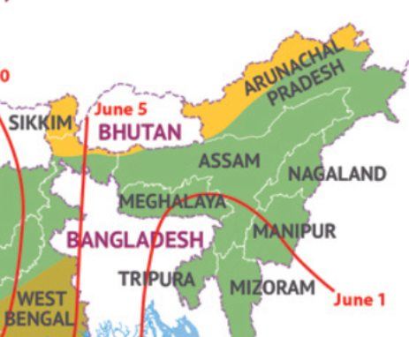
Amongst the seven sisters, six of them have single temperature that is Humid subtropical. Whereas Arunachal Pradesh shares two climates, Humid Subtropical and Montane Climate.
Factors to consider…
Best transport connectivity
Best climate
Best cost to profit margin.
With respect to competition,
If the competition is more, a placed where low cost can be managed should be chosen so that we can maximize the profit margin, my hotel should have some sort of advantage w.r.t previously established hotels and their loyal customer base. It might be location or some other salient feature.
If the competition is low then judging the economy we can think of maintaining the standards to attract a broader range of customers. But this can be done only if we have a guaranteed regular visit based on tourist attraction.
- Customise the pivot charts to add/change the fields in the fields list with other fields and by using chart styles to customise the charts. (choose the data and parameters according to your choice)

- Which is the best state for setting up a hotel? Why?

- What is the average number of days the rainy season lasts in Indian states?
June 1 and October 15
Average number of days the rainy season lasts: 177
YEAR | JAN | FEB | MAR | APR | MAY | JUN | JUL | AUG | SEP | OCT | NOV | DEC | Rainfall Month | No of Days
1991 | 14.3 | 28.1 | 27.8 | 51.7 | 68.9 | 184.7 | 279.2 | 268.1 | 140.7 | 61.8 | 30.2 | 14.7 | 7 | 210
1992 | 16 | 16.5 | 24.8 | 26.1 | 59.3 | 139.7 | 262.5 | 274 | 171.7 | 64.7 | 41.6 | 5.6 | 6 | 180
1993 | 18.2 | 25.6 | 41.6 | 27 | 71.3 | 172.1 | 305.4 | 203.2 | 208.5 | 87.9 | 30.5 | 16.5 | 6 | 180
1994 | 25 | 27.9 | 25.2 | 45.9 | 53.1 | 205.7 | 350 | 282.2 | 149.4 | 82.8 | 25.5 | 22.6 | 6 | 180
1995 | 31.3 | 29.4 | 28.3 | 32.4 | 82.4 | 143.3 | 323.4 | 269 | 179 | 78 | 36.8 | 9.2 | 6 | 180
1996 | 22.9 | 23.2 | 32.1 | 31.4 | 56 | 185.7 | 262.1 | 292.4 | 146.1 | 100.5 | 13.6 | 16.9 | 6 | 180
1997 | 14.3 | 10.4 | 30.3 | 46 | 48.6 | 171.7 | 281.5 | 261.9 | 151.4 | 61.1 | 57.6 | 48.3 | 6 | 180
1998 | 16.4 | 28.2 | 39.1 | 36.3 | 49.2 | 163.9 | 278.4 | 243.8 | 196.5 | 107.4 | 39.3 | 10.3 | 5 | 150
1999 | 13.7 | 11.2 | 8.8 | 19.3 | 94.9 | 169.9 | 261.7 | 213.2 | 183 | 117.2 | 20 | 3.7 | 6 | 180
2000 | 18.4 | 28.2 | 17.9 | 34.7 | 71.6 | 179 | 263.5 | 221.1 | 134.5 | 41.9 | 14.6 | 10 | 5 | 150
2001 | 6.7 | 11.6 | 19.9 | 44.6 | 62.9 | 221.2 | 281.1 | 205.5 | 111 | 100.4 | 19.7 | 16.1 | 6 | 180
2002 | 17.1 | 20.1 | 23.8 | 38.6 | 59.8 | 172.6 | 143.8 | 246.1 | 137.9 | 55.6 | 15.6 | 5 | 6 | 180
2003 | 7.3 | 42.3 | 36.7 | 36.6 | 40.1 | 169.3 | 306.5 | 243.6 | 183.4 | 92.7 | 11.5 | 17.2 | 5 | 150
2004 | 25.1 | 10 | 12.8 | 55.2 | 80.6 | 171.1 | 250.5 | 254 | 131.5 | 95 | 17.9 | 2.8 | 7 | 210
2005 | 28.1 | 41.8 | 42.5 | 37.7 | 46.1 | 143.2 | 334.1 | 190.1 | 206.9 | 99.3 | 27.2 | 11.2 | 5 | 150
2006 | 17.7 | 11.9 | 35.6 | 32.7 | 75 | 141.8 | 287.6 | 281.3 | 178.6 | 51.8 | 34.6 | 13.1 | 6 | 180
2007 | 1.7 | 36.7 | 35.2 | 30.6 | 46.8 | 192.5 | 286.2 | 257.4 | 206.8 | 55.7 | 14.4 | 15.3 | 5 | 150
2008 | 18.4 | 19.3 | 41.2 | 29.5 | 43.7 | 202 | 245 | 265.8 | 165.1 | 51.6 | 25.5 | 11 | 5 | 150
2009 | 12 | 12 | 14.2 | 25.1 | 56 | 85.7 | 280.7 | 192.5 | 139.4 | 71.4 | 53.7 | 11.1 | 7 | 210
2010 | 7.5 | 17 | 14 | 39 | 73.8 | 138.1 | 300.7 | 274.7 | 197.7 | 69 | 61.4 | 22.7 | 7 | 210
 |  |  |  |  |  |  |  |  |  |  |  |  |  | 177

